I'd be glad to provide a comprehensive response to the prompt, incorporating the best aspects of the previous responses and addressing any potential shortcomings:
CSS Box Model:
The CSS box model is a fundamental concept that defines how elements are rendered on a web page. It's a conceptual representation of an element as a rectangular box, divided into four main components:
- Content: The area occupied by the element's actual content, such as text or images.
- Padding: The space between the content and the border. It controls the internal spacing around the content.
- Border: The outer boundary of the element. It can be styled with color, width, and style (solid, dashed, dotted, etc.).
- Margin: The space outside the border, separating the element from neighboring elements. It controls the external spacing.
HTML Layout Example:
HTML
<!DOCTYPE html>
<html>
<head>
<title>CSS Box Model Example</title>
<style>
.box {
width: 200px;
height: 200px;
background-color: #f0f0f0;
border: 2px solid #000;
}

.content {
background-color: #fff;
padding: 10px;
}
</style>
</head>
<body>
<div class="box">
<div class="content">
This is the content area.
</div>
</div>
</body>
</html>
Use code with caution.
Visual Examples:
1. Changing Padding:
- Increase padding:
CSS
.content {
padding: 20px;
}
Use code with caution.
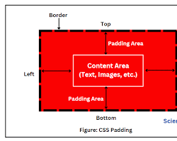Opens in a new windowwww.scientecheasy.com
element with increased padding
- Decrease padding:
CSS
.content {
padding: 5px;
}
Use code with caution.
Opens in a new windowm.youtube.com
element with decreased padding
2. Changing Margin:
- Increase margin:
CSS
.box {
margin: 20px;
}
Use code with caution.
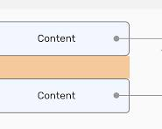Opens in a new windowishadeed.com
element with increased margin
- Decrease margin:
CSS
.box {
margin: 0;
}
Use code with caution.
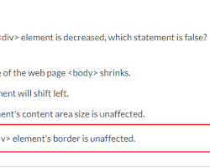Opens in a new windowwww.chegg.com
element with decreased margin
3. Changing Border:
- Change border width:
CSS
.box {
border: 4px solid #000;
}
Use code with caution.
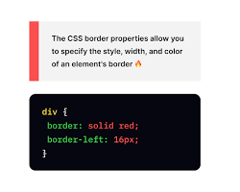Opens in a new windowapp.uxcel.com
element with a thicker border
- Change border style:
CSS
.box {
border: 2px dashed #000;
}
Use code with caution.
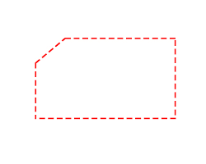Opens in a new windowstackoverflow.com
element with a dashed border
- Change border color:
CSS
.box {
border: 2px solid #f00;
}
Use code with caution.
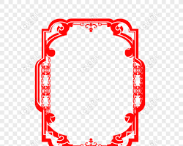Opens in a new windowlovepik.com
element with a red border
Additional Notes:
- You can apply padding, margin, and border to all four sides of an element using padding: top right bottom left and margin: top right bottom left.
- To set the same value for all sides, you can use padding: 10px or margin: 10px.
- The box model can be used to create complex layouts, such as nested elements and responsive designs.
By understanding the CSS box model and its components, you can effectively control the spacing, layout, and appearance of elements on your web pages.

